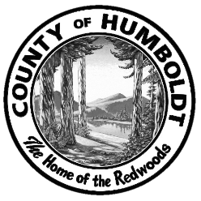
Humboldt County’s Cannabis Land Use Ordinance and California State Law require that commercial cannabis cultivators be in compliance with all laws and regulations when applying pesticides for the production of an agricultural commodity.

WHEN
SEPTEMBER 19, 2018
9:00 AM – 12:00 NOON
SPACE IS LIMITED – REGISTRATION IS FIRST COME FIRST SERVED!
REGISTER ONLINE AT: https://humboldtgov.org/Activities?selectedCategories=2

WHERE
HUMBOLDT COUNTY AGRICULTURAL CENTER
5630 S. BROADWAY, EUREKA
(707) 441-5260

Pesticide WORKSHOP For COMMERCIAL Cannabis Cultivators

The training will cover the following topics:
- Operator Identification Numbers
- Private Applicator Certificates
- Pesticide Use Reporting
- Employer Requirements and Worker Health Safety
- Understanding and Interpreting Pesticide Labels

Hosted by
Humboldt County Agricultural Commissioner’s Office
California Department of Pesticide Regulation



